Home Page

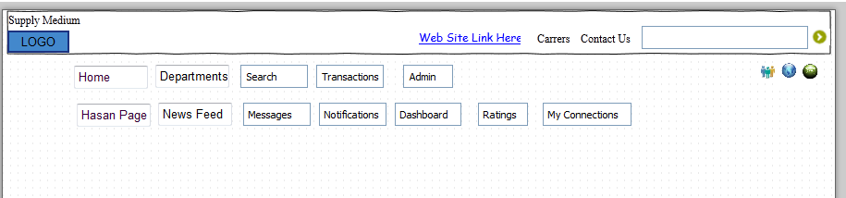

Department page

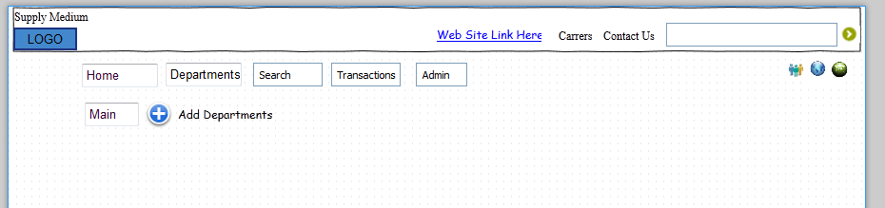

Search tab

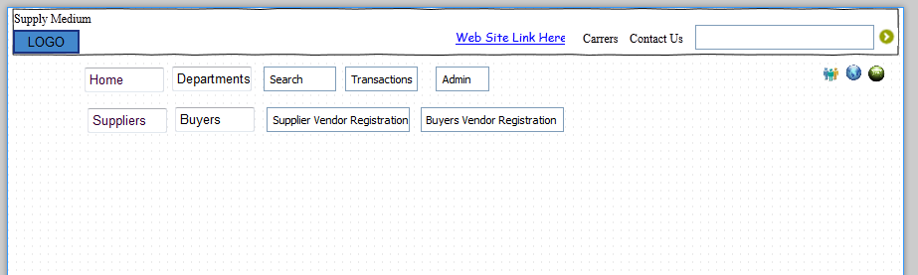

Transaction page

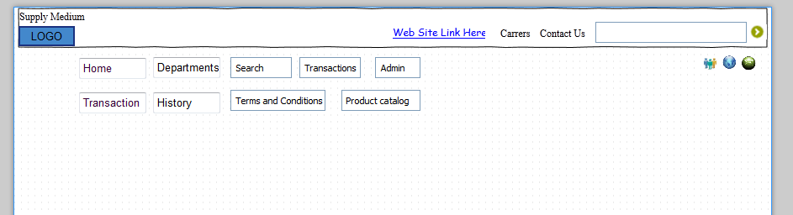

Admin

